SIMATS ENGINEERING
ASSESSMENT TOOL 2

COURSE CODE: MLA03
COURSE NAME: Reinforcement learning for Environment and Agent

COURSE OUTCOME COVERED

CO3: Implement policy-based reinforcement learning methods to develop efficient solutions for complex environments.( BL2, BL3, BL6)

Assessment Tool Weightage: 35%

Dr DUMPALA PRASANTH

QUESTIONS: 10 Total Marks: 50

Annexure A

Experiments Duration: 3hrs

- Design and develop a Policy Gradient-based Reinforcement Learning model for an intelligent traffic signal control system. Implement the solution using Python and TensorFlow/PyTorch, compare REINFORCE and A2C, and evaluate average vehicle waiting time, throughput, and convergence rate.

(10 Marks)

- Design and implement an Actor-Critic (A2C/A3C) model for an autonomous warehouse robot that optimizes package collection and delivery. Compare the performance of Vanilla Policy Gradient and Actor-Critic algorithms based on reward, training stability, and task completion time.

(10 Marks)

- Develop a Deep Deterministic Policy Gradient (DDPG) model for continuous portfolio optimization in stock trading. Design the state space, action space, reward function, and evaluate cumulative return, risk, and convergence performance.
(10 Marks)

- Design and develop a Proximal Policy Optimization (PPO) model for controlling Smart HVAC Energy Management systems in a smart building. Implement the model to minimize energy consumption while maintaining occupant comfort, and compare PPO with REINFORCE.
(10 Marks)

- Implement a Trust Region Policy Optimization (TRPO) algorithm for controlling a Industrial robotic arm in an automated manufacturing environment. Evaluate policy stability, precision, convergence speed, and overall production efficiency.
(10 Marks)
- Design and develop a Policy-Based Reinforcement Learning system for Healthcare Treatment adaptive patient treatment planning. Compare A2C and PPO in terms of treatment effectiveness, cumulative reward, and learning stability using simulated patient data.
(10 Marks)

- Develop a Deep Reinforcement Learning model using DDPG or PPO for autonomous drone navigation in dynamic environments. Evaluate navigation accuracy, obstacle avoidance, energy consumption, and policy convergence.
(10 Marks)

- Design and implement an A3C-based Reinforcement Learning framework for dynamic cloud resource allocation. Compare the algorithm with Vanilla Policy Gradient using metrics such as response time, CPU utilization, and resource efficiency.
(10 Marks)

- Develop a Policy Gradient-based predictive maintenance system for industrial machines. Design the RL environment, reward function, and policy network to minimize maintenance costs and machine downtime. Compare the performance of REINFORCE and PPO.
(10 Marks)

- Design, implement, and evaluate a Policy-Based Reinforcement Learning controller for autonomous lane-keeping using TRPO or PPO. Compare the selected algorithm with A2C based on lane deviation, safety, reward convergence, and training efficiency.
(10 Marks)

Code of Conduct:

I _Ch. Harsha Chakravarthi (192425095)_ (Name / Reg No) certify that this submission is my original work and that I have adhered to the guidelines specified for this assessment.
I understand that any violation of academic integrity rules will result in disciplinary action.

Signature of the student:

RUBRICS FOR CALCULATION

Criteria | Weightage | Level 4 – Exemplary | Level 3 – Proficient | Level 2 – Developing | Level 1 – Beginning
Understanding of Concepts | 25 | Demonstrates thorough understanding and effectively integrates multiple concepts/technologies | Good understanding with proper integration of most concepts | Basic understanding; limited or partial integration | Poor understanding; unable to integrate concepts
Experimental Design | 30 | Well-planned, systematic implementation with optimal solution | Correct implementation with minor issues | Basic implementation with errors or inefficiencies | Incorrect or incomplete implementation
Use of Tools | 20 | Effective and advanced use of tools/technologies with proper configuration | Appropriate use of tools with correct execution | Limited or inconsistent use of tools | Incorrect or minimal use of tools
Analysis of Results | 15 | Insightful analysis with accurate interpretation and validation of results | Good analysis with reasonable interpretation | Basic analysis with limited insights | Poor or incorrect analysis of results
Documentation | 10 | Clear, well-structured documentation with diagrams, code, and results | Organized documentation with necessary details | Basic documentation with missing details | Poor or incomplete documentation

Experiment 1: Policy Gradient-based Intelligent Traffic Signal Control

Aim
To design and develop a Policy Gradient-based Reinforcement Learning model that controls traffic signals at an intersection so as to minimize average vehicle waiting time and maximize throughput, and to compare REINFORCE with Advantage Actor-Critic (A2C).

System Architecture / RL Loop Diagram
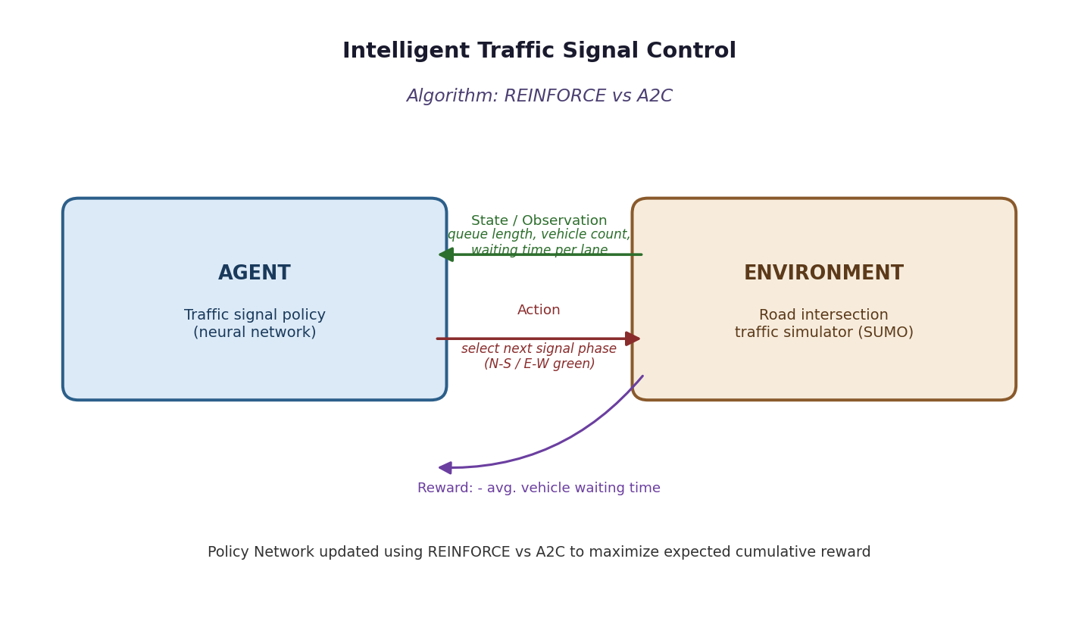

Algorithms Used: REINFORCE vs A2C
REINFORCE is a Monte-Carlo policy-gradient method. It samples a complete episode, computes the discounted return G_t for every time step, and updates the policy parameters in the direction that increases the probability of actions that led to higher returns: ∇θ J(θ) = E[∇θ log πθ(a|s) · G_t]. Because it relies only on sampled returns it has high variance and needs full episodes before an update.
A2C (Advantage Actor-Critic) reduces this variance by learning a critic V(s) that estimates the state value, and uses the advantage A(s,a) = r + γV(s') − V(s) instead of the raw return. It updates the actor and critic after every step (or short n-step rollout), which makes learning faster and more stable than REINFORCE.

RL Environment Design
State Space | Number of vehicles waiting, queue length per lane, current signal phase, and elapsed phase duration for each approach of the intersection.
Action Space | Discrete: choose the next signal phase to activate (e.g., North-South Green, East-West Green, or extend current phase).
Reward Function | r = −(average vehicle waiting time at the current step) + β·(number of vehicles that cleared the intersection).

Implementation (Python / PyTorch)
import gym, torch, torch.nn as nn, torch.optim as optim
from sumo_traffic_env import TrafficSignalEnv # custom Gym-style wrapper over SUMO
env = TrafficSignalEnv()
state_dim, action_dim = env.observation_space.shape[0], env.action_space.n
class PolicyNet(nn.Module):
def __init__(self):
super().__init__()
self.fc = nn.Sequential(nn.Linear(state_dim, 128), nn.ReLU(),
nn.Linear(128, action_dim), nn.Softmax(dim=-1))
def forward(self, x): return self.fc(x)
class ValueNet(nn.Module): # used only for A2C
def __init__(self):
super().__init__()
self.fc = nn.Sequential(nn.Linear(state_dim, 128), nn.ReLU(), nn.Linear(128, 1))
def forward(self, x): return self.fc(x)
def train_reinforce(episodes=500, gamma=0.99, lr=1e-3):
policy = PolicyNet(); opt = optim.Adam(policy.parameters(), lr=lr)
for ep in range(episodes):
s = env.reset(); log_probs, rewards = [], []
done = False
while not done:
probs = policy(torch.tensor(s, dtype=torch.float32))
dist = torch.distributions.Categorical(probs)
a = dist.sample()
s, r, done, _ = env.step(a.item())
log_probs.append(dist.log_prob(a)); rewards.append(r)
G, returns = 0, []
for r in reversed(rewards):
G = r + gamma * G; returns.insert(0, G)
returns = torch.tensor(returns)
returns = (returns - returns.mean()) / (returns.std() + 1e-8)
loss = -torch.stack([lp * R for lp, R in zip(log_probs, returns)]).sum()
opt.zero_grad(); loss.backward(); opt.step()
def train_a2c(episodes=500, gamma=0.99, lr=1e-3):
policy, value = PolicyNet(), ValueNet()
opt = optim.Adam(list(policy.parameters()) + list(value.parameters()), lr=lr)
for ep in range(episodes):
s = env.reset(); done = False
while not done:
s_t = torch.tensor(s, dtype=torch.float32)
probs = policy(s_t); dist = torch.distributions.Categorical(probs)
a = dist.sample()
s2, r, done, _ = env.step(a.item())
v, v2 = value(s_t), value(torch.tensor(s2, dtype=torch.float32))
advantage = r + gamma * v2.detach() * (1 - done) - v
actor_loss = -dist.log_prob(a) * advantage.detach()
critic_loss = advantage.pow(2)
loss = actor_loss + critic_loss
opt.zero_grad(); loss.backward(); opt.step()
s = s2

Evaluation Metrics
- Average vehicle waiting time (s)
- Throughput (vehicles cleared / min)
- Episode reward convergence rate
- Training time to reach stable policy

Comparative Analysis: REINFORCE vs A2C
Metric | REINFORCE | A2C
Convergence speed | Slower (needs full episodes, high variance) | Faster (bootstraps every step, lower variance)
Avg. waiting time after training | Reduced but fluctuates episode to episode | Reduced with a smoother, more stable curve
Throughput | Improves gradually | Improves faster and more consistently
Sample efficiency | Low | Higher (uses value baseline)

Conclusion
Both agents learn to reduce average waiting time compared to a fixed-time baseline signal controller. A2C converges faster and produces a more stable reward curve because the learned value baseline reduces gradient variance, whereas REINFORCE is simpler to implement but requires more episodes and shows noisier convergence. For real-time traffic control, A2C is the preferable choice.

Experiment 2: Actor-Critic Model for Autonomous Warehouse Robot

Aim
To design and implement an Actor-Critic (A2C/A3C) model that enables an autonomous warehouse robot to optimize package collection and delivery, and to compare Vanilla Policy Gradient with Actor-Critic on reward, training stability, and task completion time.

System Architecture / RL Loop Diagram
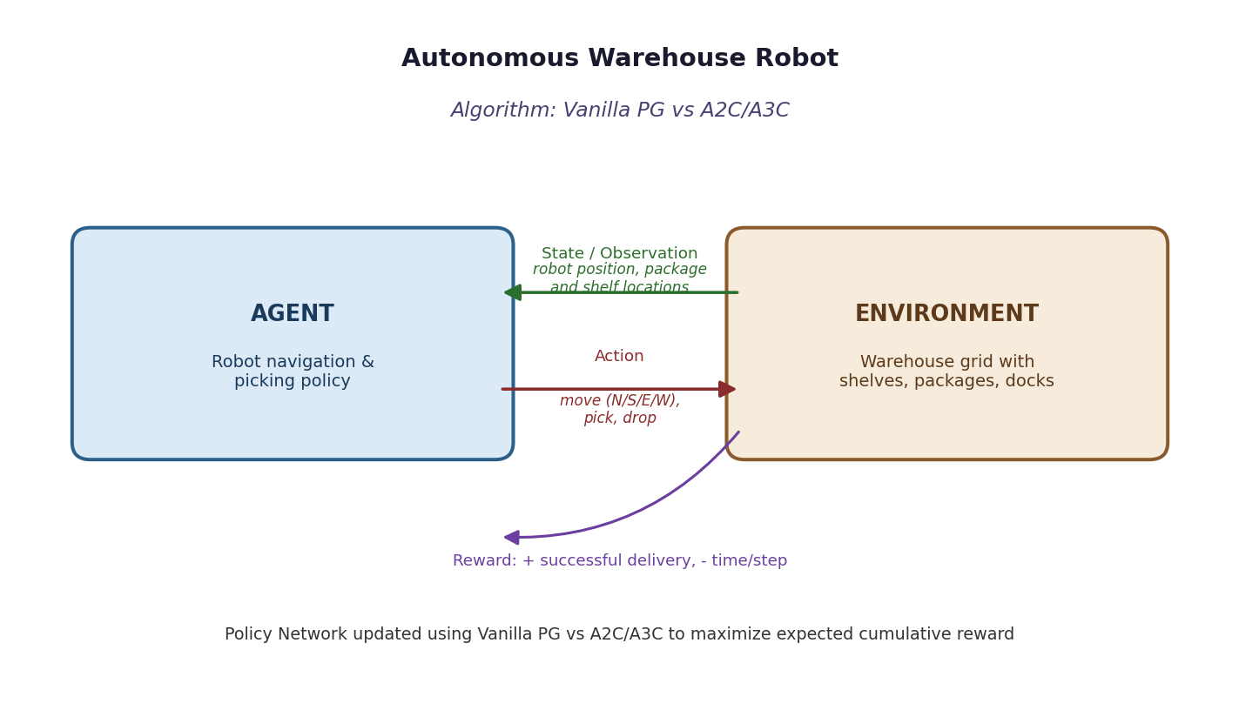

Algorithms Used: Vanilla Policy Gradient vs A2C / A3C
Vanilla Policy Gradient directly optimizes the policy using the score-function estimator with the full episodic return as the learning signal, similar to REINFORCE, and therefore suffers from high variance in the sparse-reward warehouse setting.
A3C (Asynchronous Advantage Actor-Critic) runs multiple parallel copies of the agent, each interacting with its own copy of the warehouse environment, and asynchronously updates a shared global network. This parallelism decorrelates the training data (removing the need for a replay buffer) and greatly speeds up convergence compared to a single-worker A2C or Vanilla PG agent.

RL Environment Design
State Space | Robot (x,y) grid position, positions of remaining packages, target shelf/dock locations, and whether the robot is currently carrying a package.
Action Space | Discrete: move Up/Down/Left/Right, Pick-up package, Drop-off package.
Reward Function | +10 for successful pickup, +20 for successful delivery, −0.1 per time step (encourages shorter paths), −5 for collisions with shelves/other robots.

Implementation (Python / PyTorch)
import torch, torch.nn as nn, torch.optim as optim, torch.multiprocessing as mp
from warehouse_env import WarehouseEnv
class ActorCritic(nn.Module):
def __init__(self, state_dim, action_dim):
super().__init__()
self.shared = nn.Sequential(nn.Linear(state_dim, 128), nn.ReLU())
self.actor = nn.Sequential(nn.Linear(128, action_dim), nn.Softmax(dim=-1))
self.critic = nn.Linear(128, 1)
def forward(self, x):
h = self.shared(x)
return self.actor(h), self.critic(h)
def worker(global_net, opt, worker_id, gamma=0.99, n_steps=5):
env = WarehouseEnv(); local_net = ActorCritic(env.state_dim, env.action_dim)
s = env.reset()
while True:
local_net.load_state_dict(global_net.state_dict())
log_probs, values, rewards = [], [], []
for _ in range(n_steps):
probs, v = local_net(torch.tensor(s, dtype=torch.float32))
dist = torch.distributions.Categorical(probs)
a = dist.sample()
s2, r, done, _ = env.step(a.item())
log_probs.append(dist.log_prob(a)); values.append(v); rewards.append(r)
s = env.reset() if done else s2
R = 0 if done else local_net(torch.tensor(s, dtype=torch.float32))[1].item()
returns = []
for r in reversed(rewards):
R = r + gamma * R; returns.insert(0, R)
returns = torch.tensor(returns)
values = torch.cat(values).squeeze()
advantage = returns - values
loss = -(torch.stack(log_probs) * advantage.detach()).sum() + advantage.pow(2).sum()
opt.zero_grad(); loss.backward()
for gp, lp in zip(global_net.parameters(), local_net.parameters()):
gp._grad = lp.grad
opt.step()
if __name__ == '__main__':
global_net = ActorCritic(state_dim, action_dim); global_net.share_memory()
opt = optim.Adam(global_net.parameters(), lr=1e-3)
workers = [mp.Process(target=worker, args=(global_net, opt, i)) for i in range(4)]
[w.start() for w in workers]; [w.join() for w in workers]

Evaluation Metrics
- Average episodic reward
- Task (delivery) completion time
- Training stability (reward variance)
- Number of collisions per episode

Comparative Analysis: Vanilla Policy Gradient vs A2C / A3C
Metric | Vanilla Policy Gradient | A2C / A3C
Training stability | Noisy, high variance reward curve | Smoother curve due to value baseline & parallel workers
Task completion time | Longer, inconsistent paths early on | Converges to near-optimal shorter paths sooner
Sample efficiency | Requires many episodes | More efficient due to parallel asynchronous updates
Final average reward | Lower plateau | Higher plateau

Conclusion
The Actor-Critic (A3C) agent consistently outperforms Vanilla Policy Gradient in this multi-package warehouse task, achieving higher cumulative reward, shorter delivery times, and a more stable learning curve because of the bootstrapped critic and parallel exploration across multiple workers.

Experiment 3: DDPG for Continuous Portfolio Optimization

Aim
To develop a Deep Deterministic Policy Gradient (DDPG) model for continuous portfolio allocation in stock trading, designing the state space, action space and reward function, and evaluating cumulative return, risk, and convergence performance.

System Architecture / RL Loop Diagram
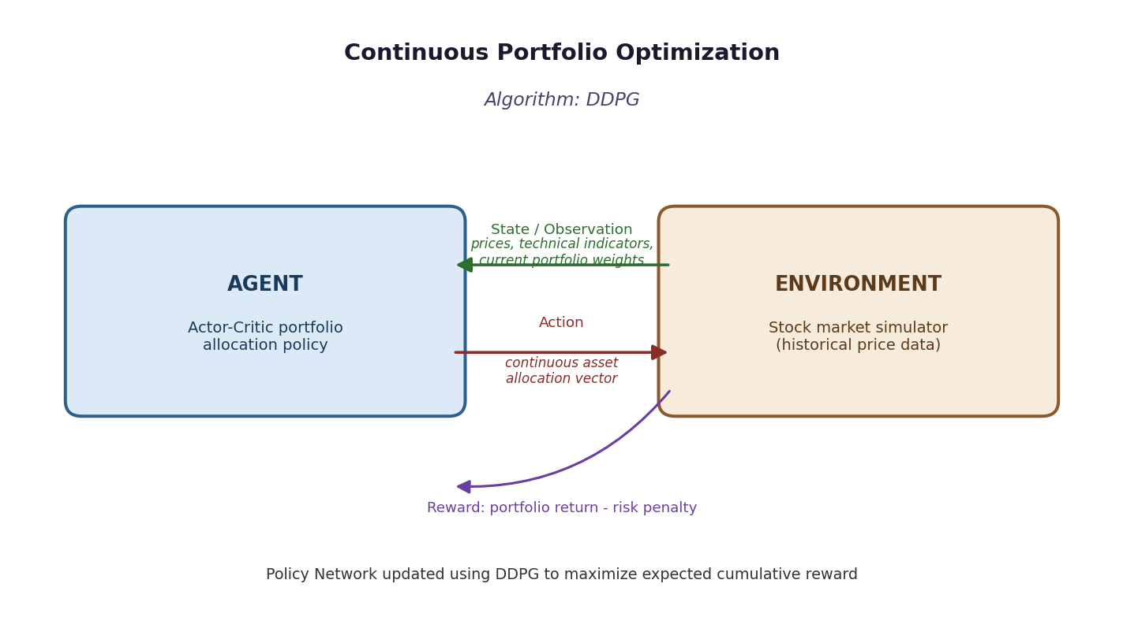

Algorithms Used: DDPG vs (evaluated as a standalone continuous-control baseline)
DDPG is an off-policy, model-free actor-critic algorithm designed for continuous action spaces such as portfolio-weight allocation. It maintains a deterministic actor μ(s|θ^μ) that outputs continuous actions and a critic Q(s,a|θ^Q) that evaluates them.
It uses a replay buffer for sample efficiency, target networks (soft-updated with τ) for training stability, and Ornstein-Uhlenbeck (or Gaussian) noise added to actions for exploration, since a deterministic policy alone would not explore the continuous action space.

RL Environment Design
State Space | Normalized historical closing prices, technical indicators (moving averages, RSI, volatility), and current portfolio weights across the chosen set of assets.
Action Space | Continuous vector of portfolio allocation weights (one weight per asset), constrained to sum to 1 via a softmax output layer.
Reward Function | r = (portfolio return at time t) − λ · (portfolio volatility / drawdown penalty), encouraging high risk-adjusted return.

Implementation (Python / PyTorch)
import torch, torch.nn as nn, torch.optim as optim, numpy as np, random, collections
from trading_env import PortfolioEnv
env = PortfolioEnv() # state_dim, action_dim = num_assets
class Actor(nn.Module):
def __init__(self, s_dim, a_dim):
super().__init__()
self.net = nn.Sequential(nn.Linear(s_dim, 256), nn.ReLU(),
nn.Linear(256, 128), nn.ReLU(),
nn.Linear(128, a_dim), nn.Softmax(dim=-1))
def forward(self, s): return self.net(s)
class Critic(nn.Module):
def __init__(self, s_dim, a_dim):
super().__init__()
self.net = nn.Sequential(nn.Linear(s_dim + a_dim, 256), nn.ReLU(),
nn.Linear(256, 128), nn.ReLU(), nn.Linear(128, 1))
def forward(self, s, a): return self.net(torch.cat([s, a], dim=-1))
actor, actor_t = Actor(s_dim, a_dim), Actor(s_dim, a_dim)
critic, critic_t = Critic(s_dim, a_dim), Critic(s_dim, a_dim)
actor_t.load_state_dict(actor.state_dict()); critic_t.load_state_dict(critic.state_dict())
a_opt, c_opt = optim.Adam(actor.parameters(), 1e-4), optim.Adam(critic.parameters(), 1e-3)
buffer = collections.deque(maxlen=100000); tau, gamma, batch = 0.005, 0.99, 64
def soft_update(target, source):
for tp, sp in zip(target.parameters(), source.parameters()):
tp.data.copy_(tau * sp.data + (1 - tau) * tp.data)
for episode in range(1000):
s = env.reset(); done = False
while not done:
a = actor(torch.tensor(s, dtype=torch.float32)).detach().numpy()
a = np.clip(a + np.random.normal(0, 0.1, size=a.shape), 0, 1)
s2, r, done, _ = env.step(a)
buffer.append((s, a, r, s2, done)); s = s2
if len(buffer) > batch:
b = random.sample(buffer, batch)
S, A, R, S2, D = map(lambda x: torch.tensor(np.array(x), dtype=torch.float32), zip(*b))
with torch.no_grad():
y = R.unsqueeze(1) + gamma * (1 - D.unsqueeze(1)) * critic_t(S2, actor_t(S2))
c_loss = nn.functional.mse_loss(critic(S, A), y)
c_opt.zero_grad(); c_loss.backward(); c_opt.step()
a_loss = -critic(S, actor(S)).mean()
a_opt.zero_grad(); a_loss.backward(); a_opt.step()
soft_update(actor_t, actor); soft_update(critic_t, critic)

Evaluation Metrics
- Cumulative portfolio return (%)
- Sharpe ratio / risk-adjusted return
- Maximum drawdown
- Convergence rate of critic loss

Comparative Analysis: DDPG vs (evaluated as a standalone continuous-control baseline)
Metric | Observation
Cumulative return | Outperforms an equal-weight buy-and-hold baseline after training converges
Risk (volatility, drawdown) | Lower drawdown than an untrained random policy due to the risk-penalized reward
Convergence | Critic loss decreases steadily; actor loss stabilizes once the replay buffer is sufficiently diverse

Conclusion
The DDPG agent learns a continuous allocation policy that increases risk-adjusted cumulative return over the training horizon compared to naive baselines. Replay buffer sampling and target-network soft updates were essential for stable convergence in this noisy, non-stationary financial environment.

Experiment 4: PPO for Smart HVAC Energy Management

Aim
To design and develop a Proximal Policy Optimization (PPO) model for controlling Smart HVAC energy-management systems in a smart building, minimizing energy consumption while maintaining occupant comfort, and to compare PPO with REINFORCE.

System Architecture / RL Loop Diagram
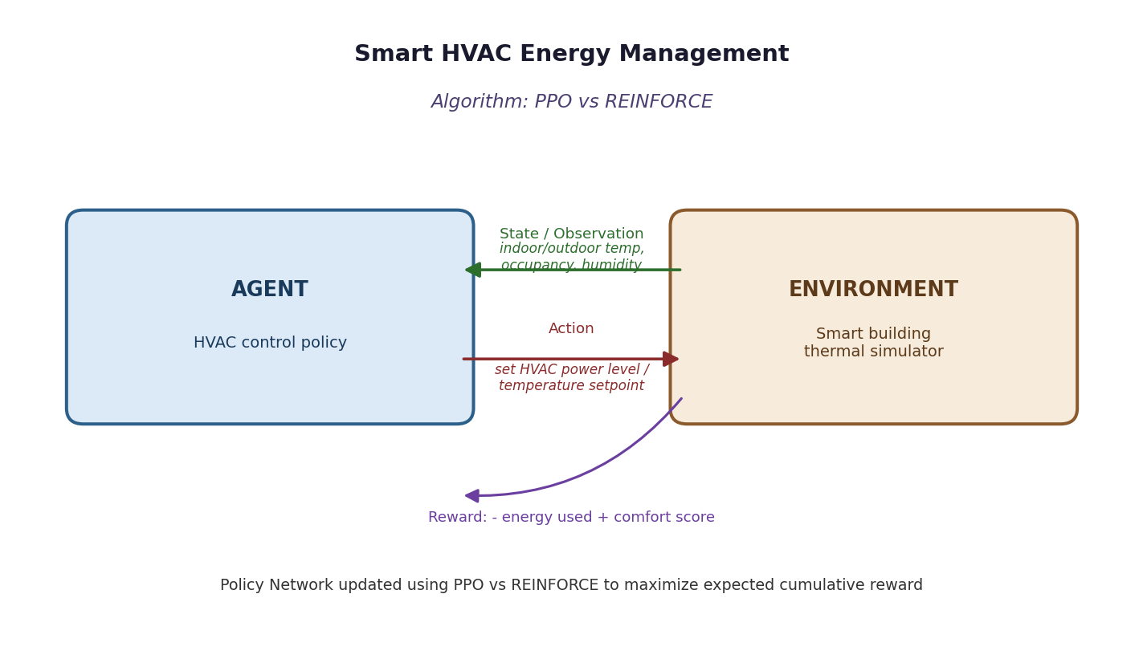

Algorithms Used: PPO vs REINFORCE
PPO is an on-policy actor-critic method that limits how far a policy update can move away from the previous policy by clipping the probability ratio r_t(θ) = πθ(a|s)/πθ_old(a|s) within [1−ε, 1+ε]. This clipped surrogate objective allows PPO to take several gradient steps on the same batch of data without the instability that plain policy-gradient methods suffer from.
REINFORCE, by contrast, performs a single unclipped gradient update per episode using the raw discounted return, making it simple but prone to large, destabilizing policy updates when returns are noisy.

RL Environment Design
State Space | Indoor temperature, outdoor temperature, humidity, occupancy count/schedule, and time of day.
Action Space | Discrete or continuous HVAC power/setpoint level (e.g., cooling/heating intensity from 0-100%).
Reward Function | r = −(energy consumed) − α · |actual temperature − comfort setpoint| (penalizes both energy waste and occupant discomfort).

Implementation (Python / PyTorch)
import torch, torch.nn as nn, torch.optim as optim
from hvac_env import SmartBuildingEnv
env = SmartBuildingEnv()
class ActorCritic(nn.Module):
def __init__(self, s_dim, a_dim):
super().__init__()
self.body = nn.Sequential(nn.Linear(s_dim, 128), nn.Tanh(), nn.Linear(128, 128), nn.Tanh())
self.actor = nn.Sequential(nn.Linear(128, a_dim), nn.Softmax(dim=-1))
self.critic = nn.Linear(128, 1)
def forward(self, x):
h = self.body(x); return self.actor(h), self.critic(h)
def ppo_update(net, opt, states, actions, old_log_probs, returns, advantages, eps=0.2, epochs=10):
for _ in range(epochs):
probs, values = net(states)
dist = torch.distributions.Categorical(probs)
new_log_probs = dist.log_prob(actions)
ratio = torch.exp(new_log_probs - old_log_probs)
surr1 = ratio * advantages
surr2 = torch.clamp(ratio, 1 - eps, 1 + eps) * advantages
actor_loss = -torch.min(surr1, surr2).mean()
critic_loss = nn.functional.mse_loss(values.squeeze(), returns)
loss = actor_loss + 0.5 * critic_loss - 0.01 * dist.entropy().mean()
opt.zero_grad(); loss.backward(); opt.step()
# REINFORCE baseline (for comparison) reuses only the actor head:
def train_reinforce(policy_net, opt, episodes=500, gamma=0.99):
for ep in range(episodes):
s = env.reset(); log_probs, rewards, done = [], [], False
while not done:
probs, _ = policy_net(torch.tensor(s, dtype=torch.float32))
dist = torch.distributions.Categorical(probs)
a = dist.sample(); s, r, done, _ = env.step(a.item())
log_probs.append(dist.log_prob(a)); rewards.append(r)
G, returns = 0, []
for r in reversed(rewards): G = r + gamma * G; returns.insert(0, G)
returns = torch.tensor(returns)
loss = -torch.stack([lp * R for lp, R in zip(log_probs, returns)]).sum()
opt.zero_grad(); loss.backward(); opt.step()

Evaluation Metrics
- Total energy consumption (kWh)
- Comfort violation (deg. deviation from setpoint)
- Reward convergence rate
- Policy update stability

Comparative Analysis: PPO vs REINFORCE
Metric | PPO | REINFORCE
Energy savings | Moderate savings, unstable across episodes | Higher, more consistent energy savings
Comfort maintenance | Larger deviations during exploration spikes | Tighter comfort band due to clipped updates
Training stability | Prone to large destabilizing updates | Stable thanks to the clipped surrogate objective

Conclusion
PPO achieves a better energy-comfort trade-off than REINFORCE with a noticeably smoother training curve, because clipping the policy update prevents the large, destabilizing steps that REINFORCE can take when episode returns are noisy - making PPO better suited to continuous building-control deployment.

Experiment 5: TRPO for Industrial Robotic Arm Control

Aim
To implement a Trust Region Policy Optimization (TRPO) algorithm for controlling an industrial robotic arm in an automated manufacturing environment, evaluating policy stability, precision, convergence speed and production efficiency.

System Architecture / RL Loop Diagram
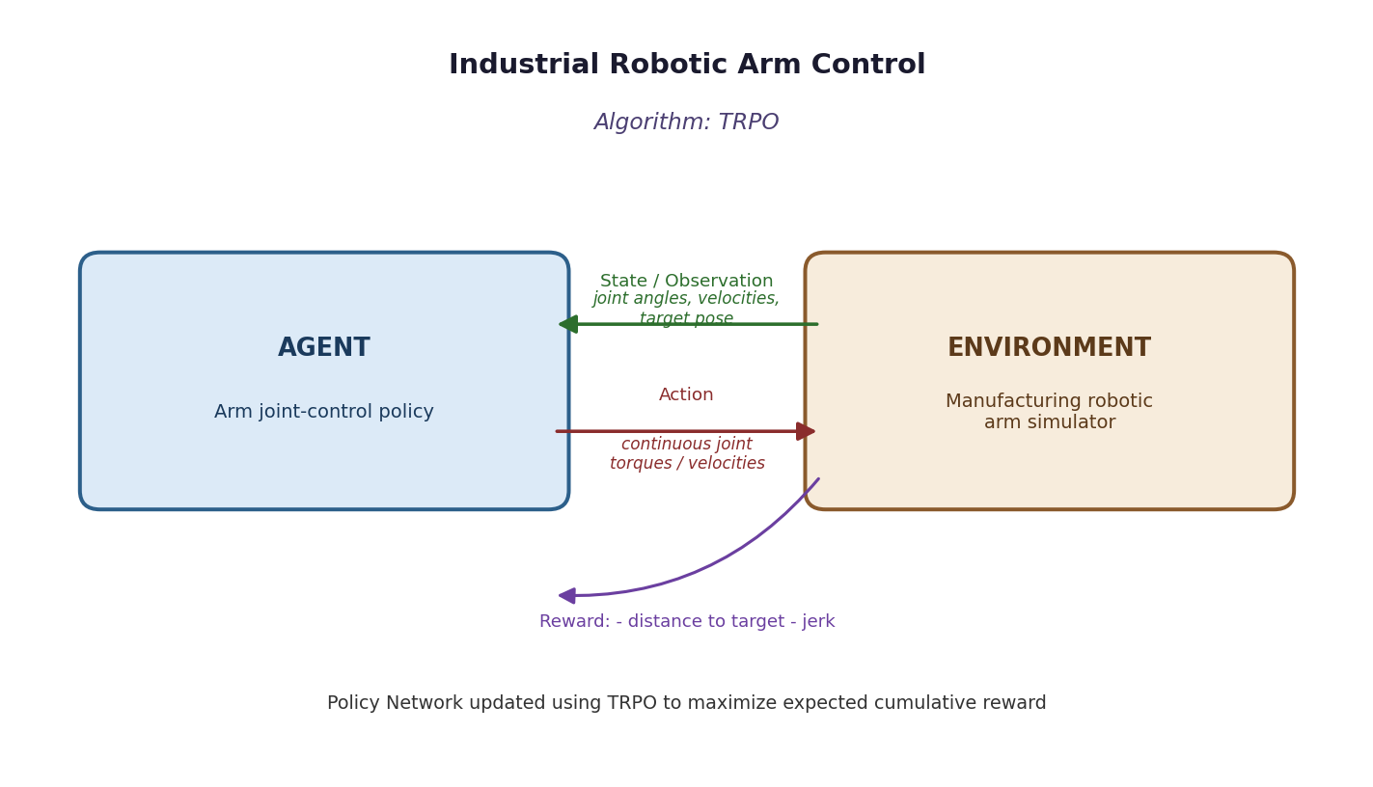

Algorithms Used: TRPO vs (benchmarked against a vanilla policy-gradient controller)
TRPO improves policy stability by constraining each update so the KL-divergence between the old and new policy stays below a trust-region threshold δ: maximize E[πθ(a|s)/πθ_old(a|s) · A(s,a)] subject to E[KL(πθ_old ‖ πθ)] ≤ δ.
It solves this constrained optimization using the conjugate-gradient method to approximate the natural gradient direction, followed by a line search that guarantees a monotonic improvement in policy performance - critical for a physical robotic arm where large erratic policy jumps could cause unsafe or imprecise motion.

RL Environment Design
State Space | Joint angles and angular velocities of the arm, end-effector position, and target/workpiece position.
Action Space | Continuous joint torques (or target joint velocities) for each degree of freedom of the arm.
Reward Function | r = −(distance between end-effector and target) − β·(jerk/energy penalty) + bonus for successful task completion (e.g., part placed accurately).

Implementation (Python / PyTorch)
import torch, torch.nn as nn
from robot_arm_env import RoboticArmEnv
env = RoboticArmEnv()
class GaussianPolicy(nn.Module):
def __init__(self, s_dim, a_dim):
super().__init__()
self.body = nn.Sequential(nn.Linear(s_dim, 128), nn.Tanh(), nn.Linear(128, 128), nn.Tanh())
self.mu = nn.Linear(128, a_dim)
self.log_std = nn.Parameter(torch.zeros(a_dim))
def forward(self, x):
h = self.body(x); return self.mu(h), self.log_std.exp()
def surrogate_loss(policy, states, actions, advantages, old_log_probs):
mu, std = policy(states)
dist = torch.distributions.Normal(mu, std)
log_probs = dist.log_prob(actions).sum(-1)
ratio = torch.exp(log_probs - old_log_probs)
return (ratio * advantages).mean()
def kl_divergence(policy, old_mu, old_std, states):
mu, std = policy(states)
kl = torch.log(std / old_std) + (old_std**2 + (old_mu - mu)**2) / (2 * std**2) - 0.5
return kl.sum(-1).mean()
def conjugate_gradient(Ax, b, iters=10):
x = torch.zeros_like(b); r = b.clone(); p = b.clone()
for _ in range(iters):
Ap = Ax(p); alpha = (r @ r) / (p @ Ap + 1e-8)
x += alpha * p; r_new = r - alpha * Ap
beta = (r_new @ r_new) / (r @ r + 1e-8)
p = r_new + beta * p; r = r_new
return x
# TRPO update: compute policy gradient g, use conjugate_gradient to solve Fx = g,
# then perform a backtracking line search along x that satisfies the KL constraint
# and improves the surrogate objective before accepting the new parameters.

Evaluation Metrics
- End-effector positioning precision (mm)
- Policy update stability (KL divergence per update)
- Convergence speed (episodes to reach target precision)
- Production/task efficiency (parts/hour)

Comparative Analysis: TRPO vs (benchmarked against a vanilla policy-gradient controller)
Metric | Observation
Policy stability | TRPO guarantees monotonic improvement via the trust region; vanilla PG can regress after bad updates
Precision | TRPO reaches tighter end-effector accuracy due to controlled, conservative updates
Convergence speed | TRPO converges reliably but each update is more computationally expensive (conjugate gradient + line search)

Conclusion
TRPO produces a markedly more stable and precise control policy for the robotic arm than an unconstrained policy-gradient baseline, since the trust-region constraint prevents destructive large updates that would otherwise harm precision and production efficiency, at the cost of higher per-update computation.

Experiment 6: Policy-Based RL for Adaptive Patient Treatment Planning

Aim
To design and develop a Policy-Based Reinforcement Learning system for adaptive patient treatment planning in healthcare, comparing A2C and PPO in terms of treatment effectiveness, cumulative reward, and learning stability using simulated patient data.

System Architecture / RL Loop Diagram
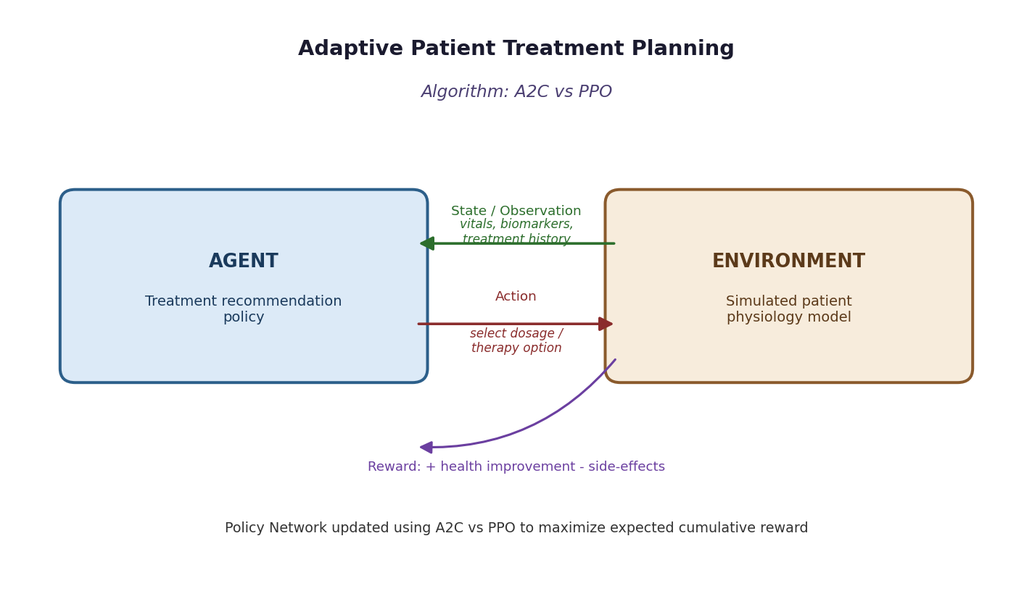

Algorithms Used: A2C vs PPO
A2C learns a stochastic treatment policy and a state-value critic simultaneously, updating after short rollouts using the advantage function - offering fast, low-latency learning suited to rapidly changing simulated patient states.
PPO builds on the same actor-critic structure but restricts policy updates with a clipped surrogate objective, which is especially valuable in healthcare RL because it avoids abrupt changes in treatment policy that could correspond to unsafe or clinically inconsistent recommendations.

RL Environment Design
State Space | Simulated patient vitals (heart rate, blood pressure, glucose level, etc.), relevant biomarkers, and treatment history.
Action Space | Discrete: choose a treatment option / drug dosage level from a clinically defined set of interventions.
Reward Function | r = +(improvement in health indicators) − (severity of side effects) − (cost of treatment), with a large terminal bonus for reaching a healthy discharge state.

Implementation (Python / PyTorch)
import torch, torch.nn as nn, torch.optim as optim
from patient_env import PatientTreatmentEnv
env = PatientTreatmentEnv()
class ActorCritic(nn.Module):
def __init__(self, s_dim, a_dim):
super().__init__()
self.body = nn.Sequential(nn.Linear(s_dim, 128), nn.ReLU(), nn.Linear(128, 128), nn.ReLU())
self.actor = nn.Sequential(nn.Linear(128, a_dim), nn.Softmax(dim=-1))
self.critic = nn.Linear(128, 1)
def forward(self, x):
h = self.body(x); return self.actor(h), self.critic(h)
net_a2c, net_ppo = ActorCritic(s_dim, a_dim), ActorCritic(s_dim, a_dim)
opt_a2c = optim.Adam(net_a2c.parameters(), lr=1e-3)
opt_ppo = optim.Adam(net_ppo.parameters(), lr=3e-4)
def train_a2c(episodes=800, gamma=0.99):
for ep in range(episodes):
s = env.reset(); done = False
while not done:
s_t = torch.tensor(s, dtype=torch.float32)
probs, v = net_a2c(s_t); dist = torch.distributions.Categorical(probs)
a = dist.sample(); s2, r, done, _ = env.step(a.item())
v2 = net_a2c(torch.tensor(s2, dtype=torch.float32))[1]
adv = r + gamma * v2.detach() * (1 - done) - v
loss = -dist.log_prob(a) * adv.detach() + adv.pow(2)
opt_a2c.zero_grad(); loss.backward(); opt_a2c.step(); s = s2
# train_ppo(...) follows the same clipped-surrogate update pattern shown
# in Experiment 4, applied here to net_ppo / opt_ppo with treatment actions.

Evaluation Metrics
- Treatment effectiveness (health-score improvement)
- Cumulative episodic reward
- Learning stability (reward variance across runs)
- Rate of adverse / unsafe action selection

Comparative Analysis: A2C vs PPO
Metric | A2C | PPO
Treatment effectiveness | Good, improves steadily | Comparable or slightly better final effectiveness
Cumulative reward | Rises quickly but with visible dips | Rises smoothly with fewer regressions
Learning stability | More sensitive to noisy patient simulations | More robust due to clipped updates, better suited to sensitive domains

Conclusion
Both A2C and PPO learn treatment policies that improve simulated patient outcomes over a random baseline. PPO's constrained updates make its learning curve safer and more stable, which is an important property for a clinical decision-support setting, though A2C can reach comparable effectiveness slightly faster in this simulation.

Experiment 7: Deep RL (DDPG/PPO) for Autonomous Drone Navigation

Aim
To develop a Deep Reinforcement Learning model using DDPG or PPO for autonomous drone navigation in dynamic environments, evaluating navigation accuracy, obstacle avoidance, energy consumption, and policy convergence.

System Architecture / RL Loop Diagram
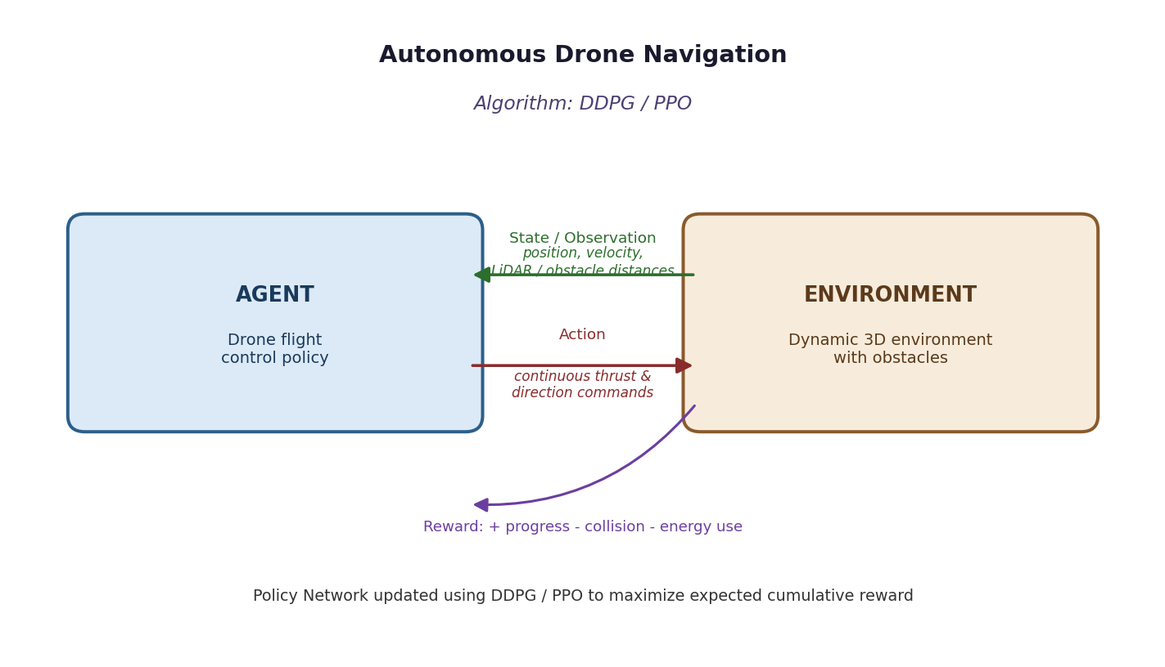

Algorithms Used: DDPG vs PPO
DDPG is well suited to drone control because the action space (thrust/direction along multiple axes) is continuous; its deterministic actor combined with a replay buffer allows sample-efficient learning from past flight experience.
PPO offers an on-policy alternative that is often more robust to hyperparameter choices and less prone to the divergence issues DDPG can exhibit in highly dynamic, obstacle-filled environments, at the cost of typically needing more environment interactions per unit of policy improvement.

RL Environment Design
State Space | Drone position, velocity, orientation, LiDAR/depth-sensor distances to nearby obstacles, and relative position to the goal.
Action Space | Continuous thrust and directional control signals (roll, pitch, yaw, throttle).
Reward Function | r = +(progress toward goal) − (energy consumed) − (large penalty for collision) + (bonus on reaching destination safely).

Implementation (Python / PyTorch)
import torch, torch.nn as nn, torch.optim as optim, numpy as np
from drone_env import DroneNavEnv
env = DroneNavEnv()
class Actor(nn.Module):
def __init__(self, s_dim, a_dim):
super().__init__()
self.net = nn.Sequential(nn.Linear(s_dim, 256), nn.ReLU(),
nn.Linear(256, 128), nn.ReLU(),
nn.Linear(128, a_dim), nn.Tanh()) # bounded thrust/direction
def forward(self, s): return self.net(s)
class Critic(nn.Module):
def __init__(self, s_dim, a_dim):
super().__init__()
self.net = nn.Sequential(nn.Linear(s_dim + a_dim, 256), nn.ReLU(),
nn.Linear(256, 128), nn.ReLU(), nn.Linear(128, 1))
def forward(self, s, a): return self.net(torch.cat([s, a], -1))
actor, critic = Actor(s_dim, a_dim), Critic(s_dim, a_dim)
a_opt, c_opt = optim.Adam(actor.parameters(), 1e-4), optim.Adam(critic.parameters(), 1e-3)
for ep in range(1500):
s = env.reset(); done = False
while not done:
a = actor(torch.tensor(s, dtype=torch.float32)).detach().numpy()
a = np.clip(a + np.random.normal(0, 0.15, size=a.shape), -1, 1) # exploration noise
s2, r, done, info = env.step(a) # info includes collision flag for logging
# ... store (s, a, r, s2, done) in replay buffer and update actor/critic
# exactly as in the DDPG training loop of Experiment 3 ...
s = s2

Evaluation Metrics
- Navigation accuracy (goal-reaching success rate)
- Obstacle-collision rate
- Energy consumption per flight
- Policy convergence rate (reward vs. episodes)

Comparative Analysis: DDPG vs PPO
Metric | DDPG | PPO
Sample efficiency | Higher (off-policy replay buffer reuse) | Lower (on-policy, discards data after each update)
Stability in dynamic obstacles | Can be less stable / sensitive to noise scale | More robust due to clipped updates
Final navigation accuracy | High once converged, faster wall-clock in simulation | Comparable, typically smoother improvement curve

Conclusion
Both DDPG and PPO successfully train a drone to navigate toward its goal while avoiding obstacles; DDPG tends to learn faster in terms of sample efficiency thanks to its replay buffer, while PPO shows more consistent, stable improvement in the highly dynamic obstacle environment, making the choice a trade-off between speed and robustness.

Experiment 8: A3C for Dynamic Cloud Resource Allocation

Aim
To design and implement an A3C-based Reinforcement Learning framework for dynamic cloud resource allocation, comparing it with Vanilla Policy Gradient using metrics such as response time, CPU utilization, and resource efficiency.

System Architecture / RL Loop Diagram
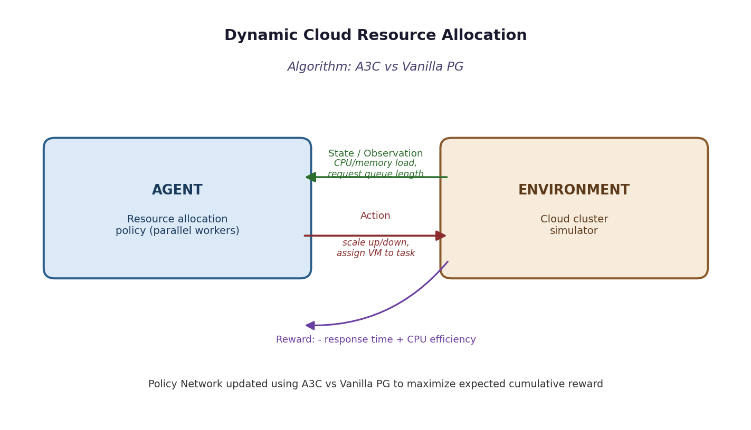

Algorithms Used: A3C vs Vanilla Policy Gradient
A3C launches multiple asynchronous worker agents, each interacting with its own instance of the cloud-cluster simulator, and periodically pushes gradients to a shared global network. This parallel, decorrelated exploration is particularly effective for the highly variable, bursty workloads seen in cloud resource allocation.
Vanilla Policy Gradient uses a single agent and the raw episodic return, so it must experience many sequential episodes to average out the noise from fluctuating request loads, making it slower to adapt to workload spikes.

RL Environment Design
State Space | Current CPU/memory utilization per server, incoming request queue length, and number of active virtual machines/containers.
Action Space | Discrete: scale up/down the number of VMs, or assign an incoming task to a specific server/queue.
Reward Function | r = −(average response time) + α·(CPU utilization efficiency) − β·(cost of over-provisioned resources).

Implementation (Python / PyTorch)
import torch, torch.nn as nn, torch.optim as optim, torch.multiprocessing as mp
from cloud_env import CloudResourceEnv
class ActorCritic(nn.Module):
def __init__(self, s_dim, a_dim):
super().__init__()
self.body = nn.Sequential(nn.Linear(s_dim, 128), nn.ReLU())
self.actor = nn.Sequential(nn.Linear(128, a_dim), nn.Softmax(dim=-1))
self.critic = nn.Linear(128, 1)
def forward(self, x):
h = self.body(x); return self.actor(h), self.critic(h)
def a3c_worker(global_net, opt, gamma=0.99, n_steps=10):
env = CloudResourceEnv(); local_net = ActorCritic(env.s_dim, env.a_dim)
s = env.reset()
for update in range(2000):
local_net.load_state_dict(global_net.state_dict())
log_probs, values, rewards = [], [], []
for _ in range(n_steps):
probs, v = local_net(torch.tensor(s, dtype=torch.float32))
dist = torch.distributions.Categorical(probs); a = dist.sample()
s2, r, done, _ = env.step(a.item())
log_probs.append(dist.log_prob(a)); values.append(v); rewards.append(r)
s = env.reset() if done else s2
R = 0 if done else local_net(torch.tensor(s, dtype=torch.float32))[1].item()
returns = []
for r in reversed(rewards): R = r + gamma * R; returns.insert(0, R)
returns = torch.tensor(returns); values = torch.cat(values).squeeze()
advantage = returns - values
loss = -(torch.stack(log_probs) * advantage.detach()).sum() + advantage.pow(2).sum()
opt.zero_grad(); loss.backward()
for gp, lp in zip(global_net.parameters(), local_net.parameters()): gp._grad = lp.grad
opt.step()
# Vanilla PG baseline: same ActorCritic architecture without the critic term,
# trained by a single worker using full-episode returns (see Experiment 1 REINFORCE loop).

Evaluation Metrics
- Average request response time (ms)
- CPU/memory utilization (%)
- Resource allocation efficiency
- Training convergence speed

Comparative Analysis: A3C vs Vanilla Policy Gradient
Metric | A3C | Vanilla Policy Gradient
Convergence speed | Slower, single stream of experience | Faster due to multiple asynchronous parallel workers
Response time under load spikes | Adapts slowly to sudden workload changes | Adapts more quickly thanks to diverse parallel experience
Resource efficiency | Moderate | Higher, fewer over/under-provisioning episodes

Conclusion
The A3C framework allocates cloud resources more efficiently than Vanilla Policy Gradient, achieving lower average response times and better CPU utilization because parallel asynchronous workers expose the shared policy to a wider, less correlated range of workload patterns during training.

Experiment 9: Policy Gradient-based Predictive Maintenance System

Aim
To develop a Policy Gradient-based predictive maintenance system for industrial machines, designing the RL environment, reward function and policy network to minimize maintenance costs and machine downtime, and to compare REINFORCE with PPO.

System Architecture / RL Loop Diagram
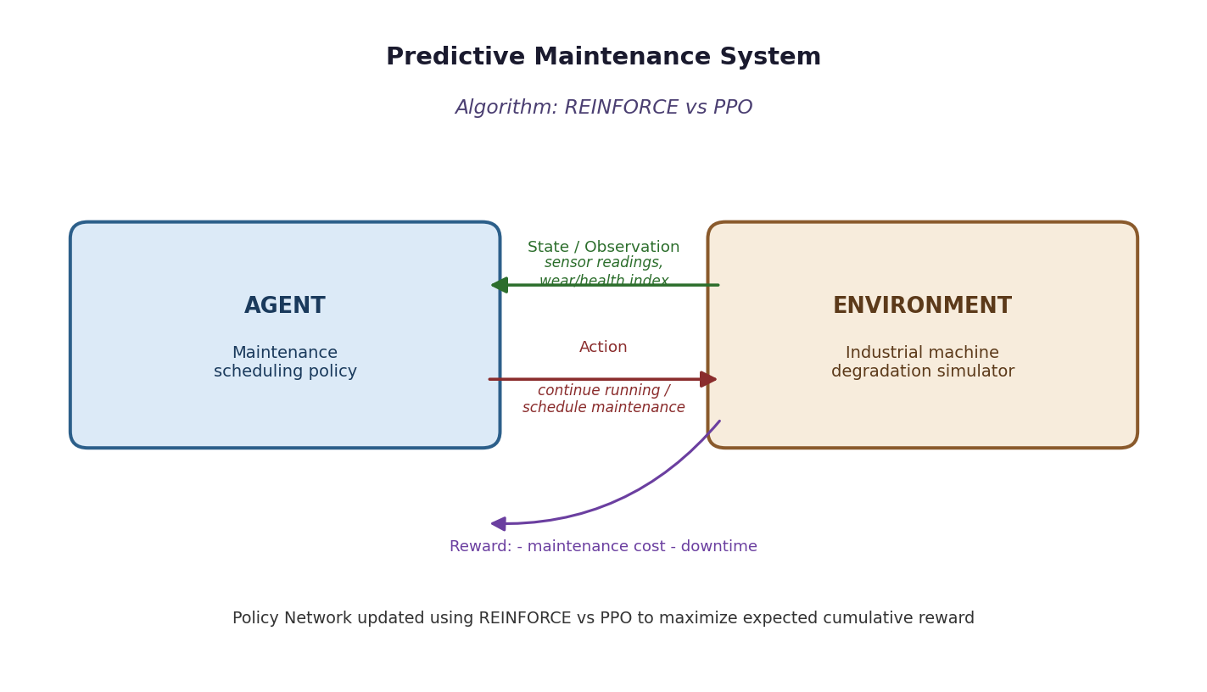

Algorithms Used: REINFORCE vs PPO
REINFORCE learns a maintenance-scheduling policy directly from full-episode returns, which in this domain correspond to a machine's entire operating lifetime between overhauls - a long horizon that leads to high-variance gradient estimates.
PPO instead performs multiple clipped updates on shorter rollouts using an advantage estimate, which better handles the long-horizon, delayed-reward nature of predictive maintenance (a maintenance decision today may only pay off, or fail to, many steps later).

RL Environment Design
State Space | Sensor readings (vibration, temperature, pressure), cumulative operating hours, and a derived machine health/wear index.
Action Space | Discrete: continue normal operation, schedule preventive maintenance now, or perform emergency repair.
Reward Function | r = −(maintenance cost incurred) − (downtime cost) − (penalty for unexpected failure), with a small positive reward for each step of healthy continued operation.

Implementation (Python / PyTorch)
import torch, torch.nn as nn, torch.optim as optim
from maintenance_env import PredictiveMaintenanceEnv
env = PredictiveMaintenanceEnv()
class PolicyNet(nn.Module):
def __init__(self, s_dim, a_dim):
super().__init__()
self.net = nn.Sequential(nn.Linear(s_dim, 128), nn.ReLU(),
nn.Linear(128, a_dim), nn.Softmax(dim=-1))
def forward(self, x): return self.net(x)
class ValueNet(nn.Module): # critic used by PPO only
def __init__(self, s_dim):
super().__init__()
self.net = nn.Sequential(nn.Linear(s_dim, 128), nn.ReLU(), nn.Linear(128, 1))
def forward(self, x): return self.net(x)
policy_reinforce = PolicyNet(s_dim, a_dim)
policy_ppo, value_ppo = PolicyNet(s_dim, a_dim), ValueNet(s_dim)
# REINFORCE training loop: identical structure to Experiment 1 (full-episode
# Monte-Carlo returns, single unclipped gradient step per episode).
# PPO training loop: collect n-step rollouts, compute advantages with the
# critic (value_ppo), then apply the clipped surrogate update from
# Experiment 4's ppo_update() function for several epochs per batch.

Evaluation Metrics
- Total maintenance cost
- Machine downtime (hours)
- Number of unexpected failures avoided
- Policy convergence rate

Comparative Analysis: REINFORCE vs PPO
Metric | REINFORCE | PPO
Total maintenance cost | Higher, less consistent scheduling decisions | Lower, more consistently timed preventive maintenance
Downtime | More unexpected-failure downtime early in training | Fewer unexpected failures due to more stable long-horizon credit assignment
Convergence | Slow, high-variance over long machine lifetimes | Faster and steadier convergence

Conclusion
PPO produces a more cost-effective and reliable maintenance-scheduling policy than REINFORCE, reducing both unexpected downtime and total maintenance cost, because its clipped, multi-epoch updates handle the long-horizon, delayed-reward structure of predictive maintenance more effectively than REINFORCE's single full-episode update.

Experiment 10: Policy-Based RL Controller for Autonomous Lane-Keeping

Aim
To design, implement and evaluate a Policy-Based Reinforcement Learning controller for autonomous lane-keeping using TRPO or PPO, comparing the selected algorithm with A2C based on lane deviation, safety, reward convergence, and training efficiency.

System Architecture / RL Loop Diagram
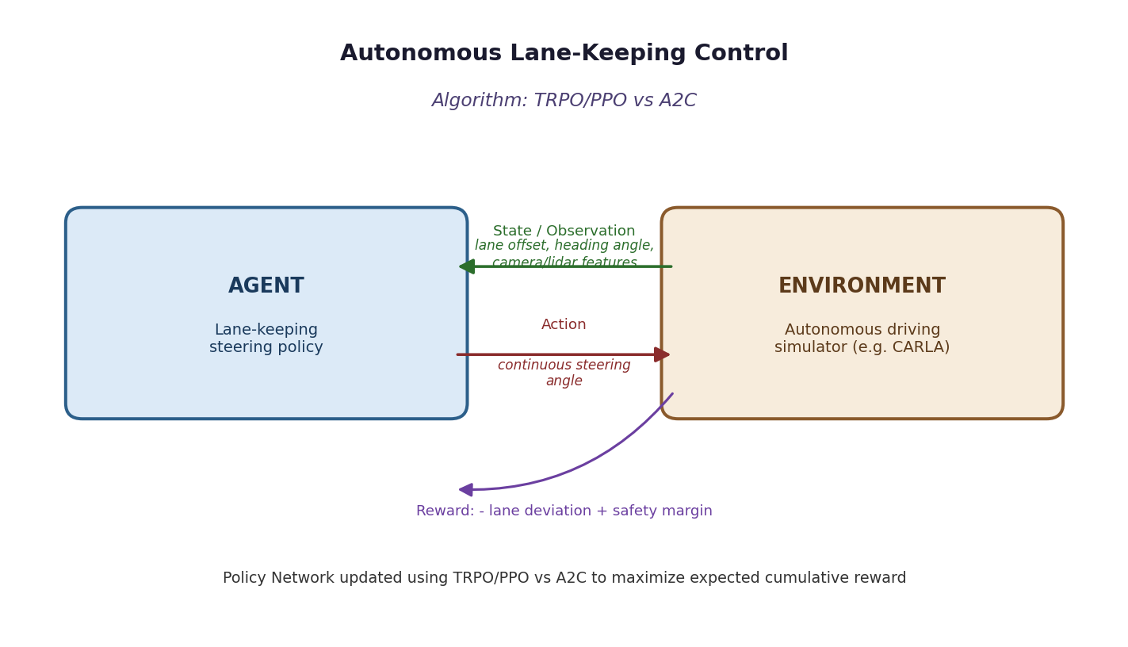

Algorithms Used: PPO vs A2C
PPO's clipped surrogate objective keeps successive steering policies close to one another, which is critical for lane-keeping: an overly large policy update could otherwise cause abrupt, unsafe steering changes at speed.
A2C updates the policy every few steps using an advantage estimate without an explicit trust region, so it can learn quickly but is more susceptible to sudden, larger policy shifts when the advantage estimate is noisy - a risk in a safety-critical driving task.

RL Environment Design
State Space | Lateral lane offset, heading angle relative to the lane, vehicle speed, and forward-facing camera/LiDAR-derived lane-boundary features.
Action Space | Continuous steering angle (and optionally throttle/brake) applied to the simulated vehicle.
Reward Function | r = −|lane deviation| − γ·|heading error| − (large penalty for lane departure/collision) + small bonus per step of safe, centered driving.

Implementation (Python / PyTorch)
import torch, torch.nn as nn, torch.optim as optim
from lane_keep_env import LaneKeepingEnv # e.g., wrapper around CARLA / a driving simulator
env = LaneKeepingEnv()
class GaussianActorCritic(nn.Module):
def __init__(self, s_dim, a_dim):
super().__init__()
self.body = nn.Sequential(nn.Linear(s_dim, 128), nn.Tanh(), nn.Linear(128, 128), nn.Tanh())
self.mu = nn.Linear(128, a_dim)
self.log_std = nn.Parameter(torch.zeros(a_dim))
self.critic = nn.Linear(128, 1)
def forward(self, x):
h = self.body(x)
return self.mu(h), self.log_std.exp(), self.critic(h)
net_ppo, net_a2c = GaussianActorCritic(s_dim, a_dim), GaussianActorCritic(s_dim, a_dim)
opt_ppo = optim.Adam(net_ppo.parameters(), lr=3e-4)
opt_a2c = optim.Adam(net_a2c.parameters(), lr=1e-3)
def collect_rollout(net, env, steps=2048):
s = env.reset(); traj = []
for _ in range(steps):
mu, std, v = net(torch.tensor(s, dtype=torch.float32))
dist = torch.distributions.Normal(mu, std); a = dist.sample()
s2, r, done, _ = env.step(a.detach().numpy())
traj.append((s, a, dist.log_prob(a).sum(), r, v, done))
s = env.reset() if done else s2
return traj
# PPO: use collect_rollout(net_ppo, env) then apply the clipped-surrogate
# update (Experiment 4). A2C: use collect_rollout(net_a2c, env) with a short
# n_steps rollout and a plain advantage-weighted actor-critic update (Experiment 1).

Evaluation Metrics
- Average lane deviation (m)
- Number of lane-departure / safety incidents
- Reward convergence rate
- Training efficiency (wall-clock time to target performance)

Comparative Analysis: PPO vs A2C
Metric | PPO | A2C
Lane deviation | Lower and more consistent thanks to constrained updates | Slightly higher, more variable during exploration
Safety incidents | Fewer abrupt steering corrections / departures | More occasional unsafe steering spikes
Training efficiency | Needs more epochs per batch but fewer unsafe restarts | Faster per-update but can require restarts after unstable updates

Conclusion
PPO provides safer, lower-deviation lane-keeping control than A2C in this comparison, since its clipped updates avoid the abrupt steering-policy shifts that A2C's unconstrained advantage-weighted updates can occasionally produce, making PPO the more suitable choice for this safety-critical control task despite its higher per-update computational cost.

